NEDSS Training Exercises for
Module 5: Tuberculosis, TB Disease Only, & Comprehensive TB Treatment Details Tab

Overview:
- This module contains three exercises, #7, 8, & 9.
- When you have finished, email your supervisor your responses.

Instructions
Exercise #7, the Tuberculosis tab:
Enter data in the Initial Evaluation section.
When you get to the question “TB Symptom Screening Performed”, select YES and enter a past date.
Next, select YES to “Is patient symptomatic?”

You have been provided the following data. Enter this in the Symptom Screening Repeating Block:
Cough (persistent x3 weeks) Onset April 3, 2023
Fever/chills Onset July 1, 2023
Weight loss (>10%) Onset July 1, 2023

- Provide a screenshot of the updated Symptom Screening Repeating Block:
Screenshot should look like this, with those exact dates and s/s:
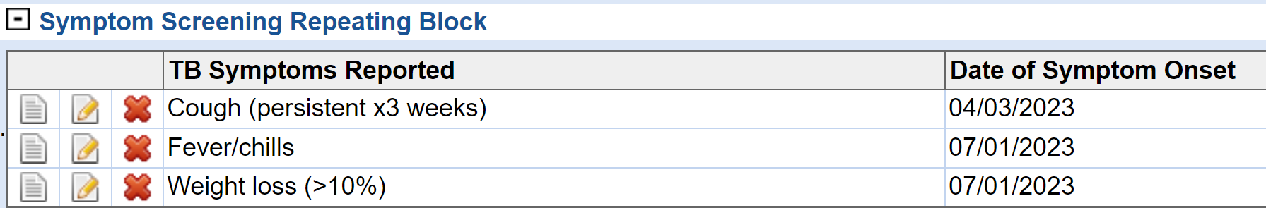

- What is a quick, accurate way to enter “No” if the patient had no Medical Risk Factors noted under the Risk Factors section?

Enter “N” and then the tab key to quickly select No.

- In the Chest Imaging section, enter any type of chest study with any date and any data results you choose. Add at least 2 and provide a screen shot of the “additional Chest Imaging” repeating block:

Review Screenshot of at least 1 of the 2 radiology results:
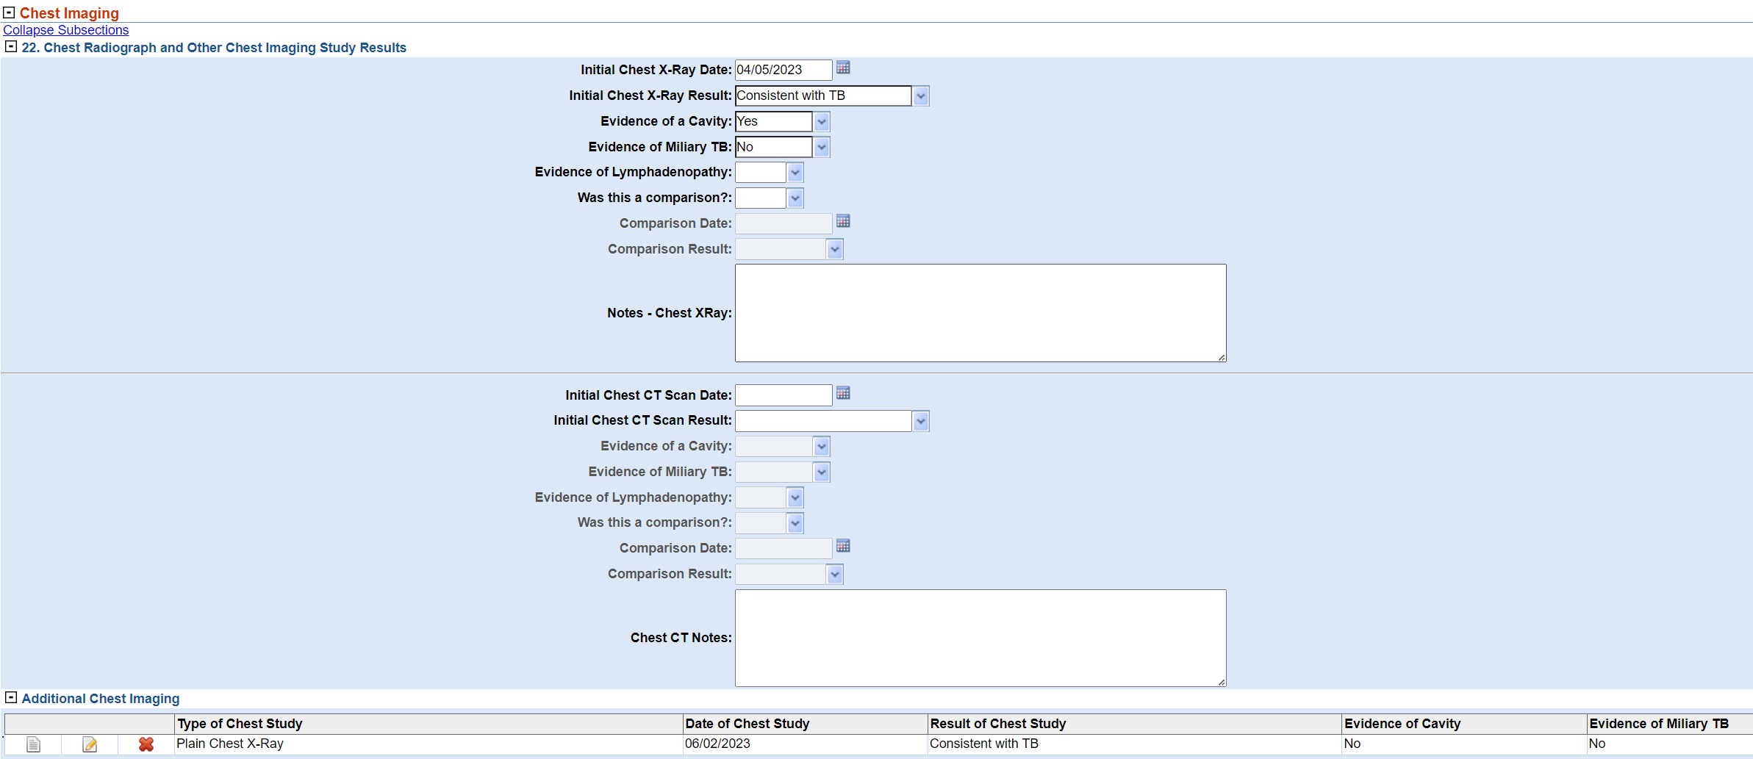
Exercise #8, the TB Disease ONLY tab:
- Enter any past date in the “Date of Illness Onset or Symptom Start Date” field. Next, indicate Pulmonary as Site of TB Disease. Provide a screenshot of this.

Review screenshot of them selecting Pulmonary as site of TB disease
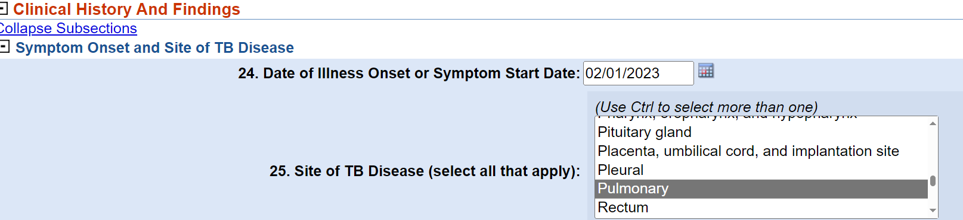
- Under the Initial Treatment Information section, what happens when you select the grey box “Standard Regimen (4)”?
The first 4 medications are selected as Yes.
- In the Case Outcome section, Sputum Culture Conversion Documented sub-section, what fields are not editable if you select “No” to the question “Sputum Culture Conversion Documented?” Select all that apply:

☒ If YES, date specimen collected for FIRSST consistently negative sputum culture
☐ If No, reason for not documenting sputum culture conversion
☒ Other if No, reason for not documenting sputum culture conversion

Exercise #9, the Comprehensive TB Treatment Details tab:
Enter an Initial Treatment Type as “Drug Susceptible TB (Known or Suspected). Provide dates in the Treatment Details subsection. Skip the Treatment Ordering Provider subsection. Now, list three drugs, a start and stop date, and dosage in the Medications subsection.

- Provide a screenshot of the drugs in the repeating block:
Screenshot should have at least 3 medications with state/stop date and dosages:
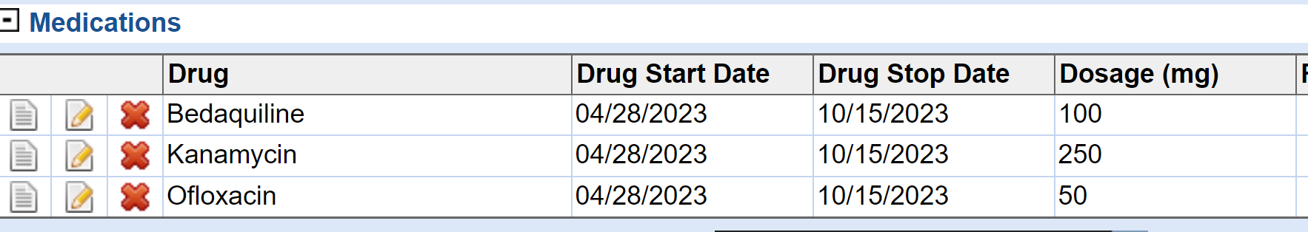

- If you noticed a mistake in the repeating block of drugs, what would you click on to easily delete the row?

The red X in the row to be deleted.

