Plano Independent School District
School Health
Chest Physiotherapy Protocol

Purpose
Chest physiotherapy (CPT) is the term for a group of treatments designed to improve respiratory efficiency, promote expansion of the lungs, strengthen respiratory muscles, and eliminate secretions from the respiratory system. The purpose of chest physiotherapy, is to help patients breathe more freely and to get more oxygen into the body. Chest physiotherapy includes postural drainage, chest percussion, and chest vibration, turning, deep breathing exercises, and coughing. It is usually done in conjunction with other treatments to rid the airways of secretions. These other treatments include suctioning, nebulizer treatments, and the administration of expectorant drugs.
Chest physiotherapy can be an important part of treatment of acute and chronic respiratory conditions, such as bronchitis, cystic fibrosis, pneumonia, and asthma. The student is placed in various positions to allow gravity to be used to promote drainage of secretions from the lungs and percussion of the chest wall is done to help loosen secretions for removal.
Definitions
- Anterior - situated at or directed toward the front; opposite of posterior.
- Apical – the adjective for apex, the tip of a pyramidal or rounded structure, such as the lung or the heart. For example, an apical lung tumor is a tumor located at the top of the lung.
- Basal - situated nearer the base of a pyramidal organ in relation to a specific reference point; opposite of apical.
- Clavicle - an elongated, slender, curved bone lying horizontally at the root of the neck, in the upper part of the thorax; called also known as the collar bone.
- Diaphragm - muscular wall below rib cage: a curved muscular membrane in humans and other mammals that separates the abdomen from the area around the lungs.
- Lateral – extending away from the median plane of the body, situated at or on the side
- Lingula - a small, tongue like structure, such as the projection from the lower portion of the upper lobe of the left lung.
- Chest Percussion – Airway clearance technique that involves clapping on the chest and/or back to help loosen thick secretions. Doing this makes mucus easier to expel, or cough up.
- Chest Vibration – Airway clearance that helps to gently shake mucus and secretions into the large airways, making them easier to cough up.
- High-Frequency Chest Wall Oscillation (HFCWO) – Delivered via a vest connected to a machine, which is an air compressor that delivers bursts of air to rapidly inflate and deflate the vest about 25 times per second. This creates gentle pressure and vibration on the chest, which does three things:
- Breaks up mucus, making it thinner.
- Creates “mini coughs” in the lungs, which help push the mucus out.
- Makes the cilia move faster, helping them carry the loosened mucus to the upper airways.
- Postural Drainage - an airway clearance technique that uses gravity to assist in the removal of secretions from the airways.
- Posterior - directed toward or situated at the back; opposite of anterior.
- Pulse Oximeter – measures the percentage of hemoglobin saturated with oxygen.
- Scapular – also known as the shoulder blade, is the bone that connects the humerus with the clavicle.
- Tracheobronchial Tree - an anatomic complex that includes the trachea, bronchi, and bronchial tubes. It conveys air to and from the lungs and is a primary structure in respiration.
Program Coordinator
Coordinator for District Health
Special Education Nurse Case Manager

Responsibilities
- Coordinates with Plano ISD principals and/or building manager and school nurses in the selection of employees for training.
- Assure quality improvement by revising this administrative guideline as required through the monitoring of training.
- Communicate with medical officer on issues related to care.

Medical Control
The medical advisor of the chest physiotherapy administrative guideline is the Plano ISD’s medical officer. The medical officer will direct the following:
- Medical direction in formulating the guideline.
- Review and approve the above.
- Evaluation as needed.

Applicable documents
- Guideline
- Training checklists
- Problem List
- Physician orders
- Individual Health Care Plan

Environment/Settings
CPT should be performed in a setting that allows for proper positioning and privacy of the student. Small students can be placed in the lap of a staff person. Older and larger students can be placed on a slant board, a padded wedge board, or a bed or couch with pillows to position the student.

Restrictions
CPT should generally not be performed for at least one hour after feeding or meds.

Requirements
- Current physician orders
- Consent to communicate with health care provider
- Development of IHP by RN
- Parental consent for care of student

Suggested Personnel and Training:
CPT may be administered by the school nurse, or other staff person who has had general training in CPT of the student. General training should cover the student’s specific health care needs, potential problems, and how to obtain assistance should problems occur.

Basic skills checklists will be used in competency based training in appropriate techniques and problem management. District procedures and checklists outline specific steps to be taken. Once the procedures have been mastered, the completed checklists serve as a documentation of training.

Training
- Registered nurse is the person responsible for training.
- Unlicensed personnel may be trained by an RN.
- Training is done yearly and as needed throughout the year.
- Guideline, problem list, health care practitioner orders and parent request are to be reviewed prior to training and throughout the year for review.
- Individual Health Care Plan is completed by the nurse.
- Competency checklist must be signed and dated yearly and periodically throughout the year as needed for verification of skills.
- Information is shared with other employees on a need to know basis.

Procedural Guideline
- Check doctor’s orders, IHP, PISD guidelines, and parent consent.
- Use Universal Precautions. Wash hands before and after suctioning.
- Identify and explain the procedure to the student at his/her level of understanding. Emphasize that the staff person is not “hitting” the student. Smooth muscles of the tracheobronchial tree may constrict because of fear, tension, or discomfort. Therefore, a relaxed, cooperative student will receive more effective CPT.
- Assemble all equipment: pillows, tissues, wastebasket with plastic liner, vest airway clearance system, if prescribed.
- Perform a baseline respiratory assessment. Student may be placed on a pulse oximeter during CPT because desaturation may occur.
- Place vest airway clearance system on student according to student’s individualized health care plan for percussion and vibration, if it has been prescribed. Vest airway clearance systems generally consist of an inflatable fitted vest, connected by hoses to an air pulse generator, which gently compress and release the chest wall 5-20 times per second. This process moves mucus toward the large airways where the mucus can be cleared by coughing and suctioning.
- Use the following sequence for percussing and/or vibrating each lobe of the lung:
- Place the student in one of the 11 positions. To percuss all the lobes of the lungs, the student should be placed in 11 different positions. The different positions use the principle of gravity to promote drainage of the tracheobronchial tree. The student is positioned so that the mucus collected in each bronchus is able to drain downward toward the trachea where it can be coughed or suctioned out. Placing the student is a sitting position facilitates drainage in the apical segment of the upper lobe. In the unstable student, these positions may be modified (i.e., the head down position would be inappropriate for a student with increased intracranial pressure or abdominal distention).
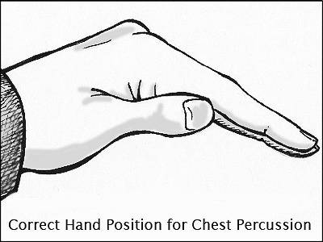
- Percuss over selected area for 1-2 minutes or student-specified amount of time. Percussion facilitates drainage by jarring the secretions. A cupped hand or soft mask creates an air pocket that softens the blow of the percussion and transfers the energy from the percussion into the lung. When using the hands to percuss, hold the hands cupped with fingers and thumb together. The cupped hand striking the chest wall should create a hollow sound. Keep the wrists loose and elbows partially flexed. Strike the chest rapidly with alternating hands. Percussion is performed over a single layer of clothing, not over buttons, snaps, or zippers.

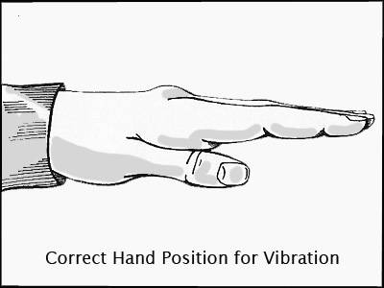
- If ordered, use vibration over specified areas. Vibration is done with a firm, shaking pressure applied to the chest wall during exhalation. Vibration may shake mucus loose or increase the velocity and turbulence of exhaled air, facilitating mucus removal.

- Instruct student to cough into tissue following percussion of each location. Discard used tissues into lined wastebaskets. Coughing is most effective if the student is sitting up so that diaphragmatic excursion is maximal. Ideally, the student should take several deep breaths and then follow the last breath with a deep cough. Initial coughing attempts may not produce sputum. As further positioning and percussion are provided, coughing will become more productive. Students with ineffective or suppressed coughs can be suctioned. (Use of vibration may break bones when students have abnormal bone conditions or are receiving medication such as steroids.)
- For percussing students over 40 pounds, the following positions may be used:
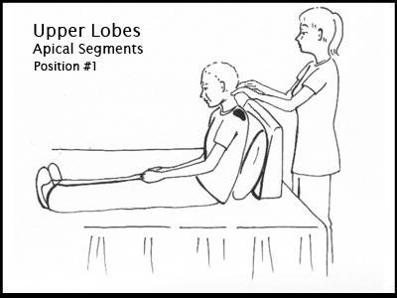
- Position 1 – Upper Lobes Apical Segments - To drain mucus from the upper lobe apical segments, the student sits in a comfortable position on a bed or flat surface and leans on a pillow against the headboard of the bed or the caregiver. The caregiver percusses and vibrates over the muscular area between the collar bone and very top of the shoulder blades (shaded areas of the diagram) on both sides for 3 to 5 minutes.

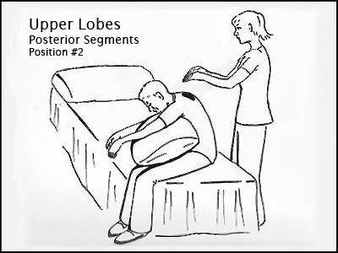
- Position 2 – Upper Lobes Posterior Segments - The patient sits comfortably in a chair or the side of the bed and leans over, arms dangling, against a pillow. The caregiver percusses and vibrates with both hands over upper back on both the right and left sides.

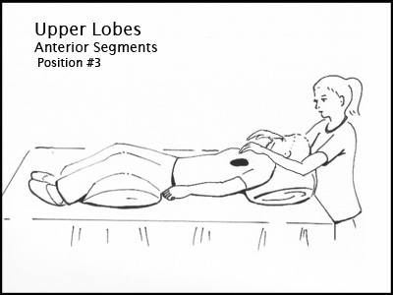
- Position 3 – Upper Lobes Anterior Segments - The patient lies flat on the bed or table with a pillow for comfort under his or her head and legs. The caregiver percusses and vibrates the right and left sides of the front of the chest, between the collar bone and nipple.

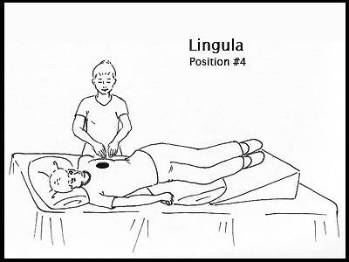
- Position 4 – Lingula - The patient lies with their head down toward the foot of the bed on the right side, hips and legs up on pillows. The body should be rotated about a quarter-turn towards the back. A pillow can also be placed behind the patient and their legs slightly bent with another pillow between the knees. The caregiver percusses and vibrates just outside the nipple area.

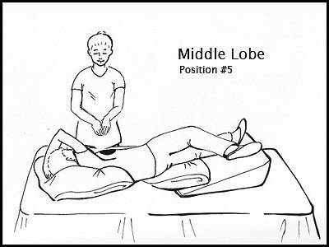
- Position 5 – Middle Lobe - The patient lays head-down on his left side, a quarter-turn toward the back with the right arm up and out of the way. The legs and hips should be elevated as high as possible. A pillow may be placed in back of the patient and between slightly bent legs. The caregiver percusses and vibrates just outside the right nipple area.

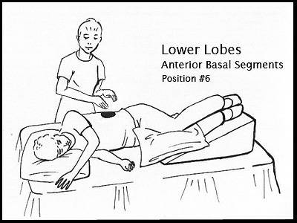
- Position 6 – Lower Lobes Anterior Basal Segments - The patient lies on his right side with his head facing the foot of the bed and a pillow behind his back. The hips and legs should be elevated as high as possible on pillows. The knees should be slightly bent and a pillow should be placed between them for comfort. The caregiver percusses and vibrates over the lower ribs on the left side, as shown in the shaded part of the diagram. This should then be repeated on the opposite side, with percussion and vibration over the lower ribs on the right side of the chest.

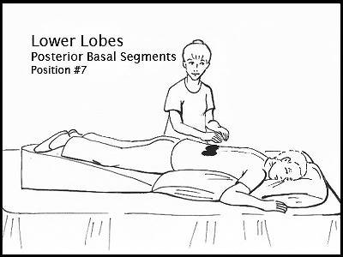
- Position 7 – Lower Lobes Posterior Basal Segments - The patients lies on his or her stomach, with the hips and legs elevated by pillows. The caregiver percusses and vibrates at the lower part of the back, over the left and right sides of the spine, careful to avoid the spine and lower ribs.

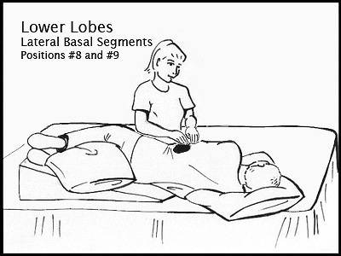
- Positions 8 and 9 – Lower Lobes Lateral Basal Segments - The patient lies on his right side, leaning forward about one-quarter of a turn with hips and legs elevated on pillows. The top leg may be flexed over a pillow for support and comfort. The caregiver percusses and vibrates over the uppermost portion of the lower part of the left ribs, as shown in the shaded area. This should then be repeated on the opposite side, with percussion and vibration over the uppermost portion of the right side of the lower ribs.

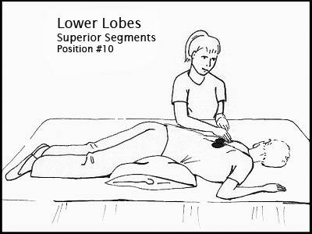
- Position 10 – Lower Lobes Superior Segments - For this position, the patient lies on his stomach on a flat bed or table. Two pillows should be placed under the hips.
The caregiver percusses and vibrates over the bottom part of the shoulder blades, on both the right and left sides of the spine, avoiding direct percussion or vibration over the spine itself.

- The techniques for percussing students under 40 pounds and other students in a sitting position are as follows:
- Person who is performing the percussing sits in a chair with legs outstretched at a 45 degree angle and with the bottom of your feet braced against a solid, upright object. A pillow is placed in front of your knees. The student is placed face down on your lap with the student’s chin resting on the pillow. This position is correct for percussing posterior basal segments of lower lobes, over area from lower scapulae to end of ribcage. Note: Young children and infants usually have no upper lobe involvement requiring percussion. Percuss with light pressure.
- Seated as before, hold student face up on your lap with the student’s head resting on the pillow. This position is correct for percussing anterior segments of lower lobes, over the area from below nipple to end of rib cage.
- At the end of the procedure, have wastebaskets contents disposed of utilizing standard precautions.
- Document CPT.

Medical Director Signature:

________________________________________ Date: _______________
Physician Signature/PISD Medical Officer

