Steps to Apply the Fix of Signature Pad
- Check Java version on your computer: make sure it is the latest Java (32 bit) version. As of February 2019, latest Java Version 8 Update 201
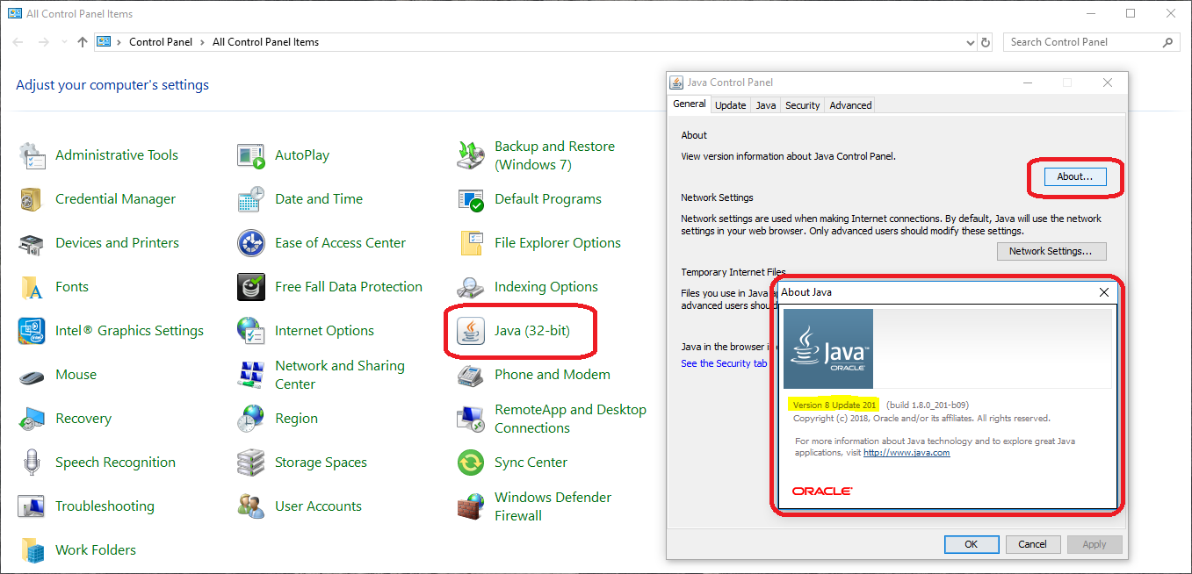
- Check Gen Print Plugin on your computer: make sure it has the latest version. As of February 2019, latest Gen Print Plugin version is 2.0.7
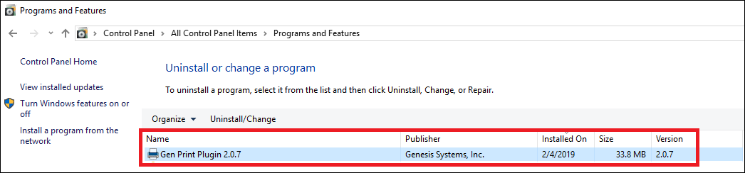

If the signature scribbles all over the place, the following steps will solve the problem
Step 1: Unplug the Topaz Signature Pad from your computer USB port.
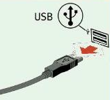
Step 2: Clear all the browsers cache that open TxEVER application. (Instruction to clear web browsers cache can be found from page 41 to page 45 of TxEVER Gen Print Plugin Installation and Troubleshooting Instructions document)
Step 3: Close all the browsers that open TxEVER application.
Step 4: Exit Gen Print Plugin by right click to the Gen Print Plugin icon on the bottom right hand side of the taskbar and select Exit.
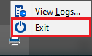
Step 5: Delete all the files in C:\Users\{your computer login ID}\AppData\Roaming\gen\
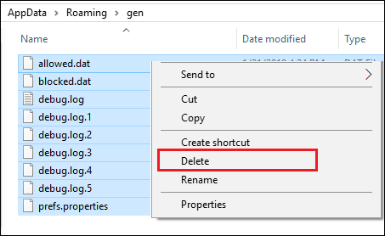
Step 6: Plug back the Topaz Signature Pad to your computer USB port.
Step 7: Open Gen Print Plugin
Step 8: Visit the TxEVER welcome page https://txever.dshs.texas.gov/TxEverUI/Welcome.htm and check the box Remember this decision and click Allow.
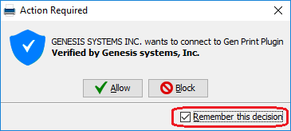
Step 9: Make sure the Gen Print Plugin version shows up and connection is Active at the bottom of the welcome page
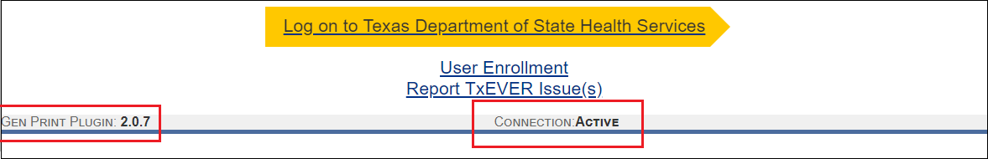
Step 10: Login to TxEVER application, at the Birth Registration page, press Ctrl + F5 to reload and apply the newest version of TxEVER.
